TRIBHUVAN UNIVERSITY
INSTITUTE OF SCIENCE AND TECHNOLOGY

Proposal on
Food Recommendation System
In partial fulfillment of the requirements for the Bachelor’s Degree in Computer Science and Information Technology
Under the Supervision of
Mr. Sudarshan Sharma
Lecturer
Department of Computer Science and Information Technology
Amrit Campus
Thamel, Kathmandu

Submitted by
Arpana Dotel(TU Roll No:28158/078)
Asmita Giri(TU Roll No:28162/078)
Sabita Basnet(TU Roll No:28229/078)
Amrit Campus
Department of Computer Science and Information Technology
Thamel, Kathmandu
Submitted to
Tribhuvan University
Institute of Science and Technology
Jan 2025

Abstract
The process of choosing a particular food item from the menu according to the user taste is very time consuming and challenging. This project studies the development of a food recommendation system using collaborative filtering approach. The problem to be addressed is how to personalize food recommendations for users by analyzing their ratings. A model-based collaborative filtering approach was used, leveraging Singular Value Decomposition to find latent factors in a user-item rating matrix. The system was modeled on sampled dataset obtained from Kaggle which contains user ratings of food items. Performance metric such as Root Mean Square Error was used to assess prediction accuracy. The result demonstrates that the model effectively predicts user rating for unrated foods and provides personalized recommendations. This study concludes that collaborative filtering is a robust method for building personalized food recommendation systems.
Keywords: recommendation system, collaborative filtering, model-based approach, singular value decomposition

Table of Contents
Abstract i
Chapter 1: Introduction 1
1.1 Introduction 1
1.2 Problem Statement 1
1.3 Objectives 1
1.4 Scope and Limitation 2
1.4.1 Scope 2
1.4.2 Limitations 2
1.5 Development Methodology 2
1.6 Report Organization 3
2. Chapter 2: Background Study and Literature Review 3
2.1 Background Study 5
2.2 Literature Review 5
Chapter 3: System Analysis 7
3.1 System Analysis 7
3.1.1 Requirement Analysis 7
3.1.2 Feasibility Analysis 9
3.1.3 Analysis 11
Chapter 4: System Design 15
4.1 Design 15
4.1.1 Database Design 15
4.1.2 Forms Design 15
4.2 Algorithm Details 16
Chapter 5: Implementation and Testing 19
5.1 Implementation 19
5.1 Tools Used 19
5.2 Testing 21
5.2.1 Test Cases for Unit Testing 21
5.2.2 Test Cases for System Testing 22
Chapter 6: Conclusion and Future Recommendations 24
6.1 Conclusion 24
6.2 Future Recommendations 24
References 25
Appendices 26

Chapter 1: Introduction

1.1 Introduction
Recommendation system is a system which recommends item to users among a large number of existing items in database. Item is anything which users consider, such as food, product, book, and newspaper. For restaurants, food recommendation systems improve customer satisfaction by providing personalized recommendations. There are two common approaches for recommendation systems which are CBF and CF. CBF recommends items based on the features of the items themselves. CF recommends items based on the preferences of similar users. It focuses on user ratings rather than item properties.
The project ‘Food Recommendation System’ is developed for particular restaurant to recommend food based on the user ratings. It is done by using model-based collaborative filtering where SVD approach is used to decompose the rating matrix into three matrices based on the latent feature. Predicted rating is calculated by performing dot product on those three matrices (U, Σ, V^{T}). The system also suggests similar food items while viewing the food detail page based on the similarity score calculated using cosine similarity considering food ingredients as attribute. It also provides fundamental e-commerce website functionalities along with recommendations features.

1.2 Problem Statement
Choosing a particular food item from a set of many food items in a restaurant is very difficult task. Restaurants with numerous options confuse the customers in choosing a food item that best suits their preferences. With the rise in online food ordering websites, a lack of recommendation leaves customers with a suboptimal experience. Customers have to spend a lot of time looking through long menus, frustratingly losing engagement. Hence, restaurants may face challenges in aligning food items to different customer preferences and thus are not able to enhance customer satisfaction and boost restaurant sales.

1.3 Objectives
The main objectives of Food Recommendation System are:
- To develop personalized recommendation system for customers based on their ratings for purchased foods.
- To suggest food items that are similar to each other by considering its ingredients.

1.4 Scope and Limitation
Scope and Limitations are described below:

1.4.1 Scope
The proposed food recommendation system is designed to benefit both customers and restaurants by leveraging modern technology for personalized suggestions. Being a webbased system, it ensures accessibility to users with devices supporting a browser and an active Internet connection.
This system enables users to explore and search for a variety of food items available in that particular restaurant. It allows customers to rate on their meals. Restaurants can utilize these insights to refine their cuisine and increase customer satisfaction. Additionally, the system generates recommendations based on users' historical purchases and ratings, helping them discover meals suited to their tastes effortlessly.

1.4.2 Limitations
The limitations of this food recommendation system are as follows:
- Since the system is web-based, users without access to the Internet will be unable to use the platform.
- The recommendation feature is limited to registered users who have provided ratings at least three times.
- In cases where users provide limited ratings, the system's ability to generate accurate recommendations may be affected.

1.5 Development Methodology
Evolutionary prototyping is a software development approach where the developer initially creates a prototype and then iteratively refines it by incorporating additional functionality or improvements based on customer feedback. This process continues until the final product takes shape. Unlike rapid or throwaway prototyping, evolutionary prototyping begins with the most well-understood requirements, whereas rapid prototyping focuses on the least understood ones. Additionally, there is no urgency in building the first prototype. Within the broader software development lifecycle, incremental development shares similarities with evolutionary prototyping, as both allow for partial system delivery and customer evaluation.

1.6 Report Organization
The report has been prepared following the guidelines provided by Tribhuvan University. The report is separated into different chapters. Each chapter consists of various sub chapters with its content. The preliminary section of the report consists of Cover and Title Page, Certificate Page, Acknowledgement, Abstract, Table of Contents, List of Abbreviations, List of Figures, List of Tables and Main Report.
The Main Report is divided into six chapters, which include:
1. Chapter 1: Introduction
It includes the general overview of the system and the project as a whole. It includes the Problem Statement, Objectives, Scope/Limitations and the Development Methodology for the project and the system being developed.

2. Chapter 2: Background Study and Literature Review
It includes the study of the current scenario/environment the system will be deployed into. It includes the study of the current trends, preferences of people, the existing systems, areas of improvement among others.

- Chapter 3: System Analysis
It includes the requirement and feasibility analysis of the system that can be generated through the studies presented in the previous two chapters. It will also include the Flowchart, ER and DFD for the system which specifies the workflow, entities, attributes and their relationships.

- Chapter 4: System Design
It includes the design of the database, forms and interface of the system. It also includes the implementation details of the selected methodology and the details of the algorithm used.

- Chapter 5: Implementation and Testing
It includes the details of the different design and development tools used and the implementation details of the modules presented in the form of code snippets of functions, classes. It also includes the testing of the system with different test cases as per the requirement.

- Chapter 6: Conclusion and Future Recommendations
It includes the summary of the system and the project as a whole. It also includes the possibilities/aspects which the system can implement in the future.

Chapter 2: Background Study and Literature Review

2.1 Background Study
Food recommendation systems help to recommend food items to customers based on their ratings. In recent years, there has been a great rise in the popularity of food recommendation systems in the restaurant industry. With a rise in data analysis and machine learning, restaurants can now use customer data to give personalized food suggestions. These systems can use different methods, like CF, CBF, and hybrid methods.
CF based recommendation system assumes that users who have similar tastes in the past will continue to share preferences in the future. CF can be further divided into: memoryBased CF and model-based CF. The former approach calculates similarities using user-item interactions between users or items using methods like cosine similarity or Pearson correlation. The later approach uses machine learning algorithms such as matrix factorization or neural networks to train a model in order to predict user-item interactions. The model learns latent factors from the user-item matrix and uses these to make recommendations. CBF approach recommends items based on their characteristics, such as ingredients. It uses cosine similarity to determine similarities between two non-zero vectors in a multi-dimensional space. It evaluates how closely aligned two vectors are by measuring the cosine of the angle between them [1] [2].
Some terminologies learned during the background study are TF-IDF, SVD, Latent feature, etc. Latent Features are the hidden features derived from user-item interaction data, typically uncovered using techniques like matrix factorization. TF-IDF is a technique that measures the importance of a word in a document relative to a collection of documents. It balances word frequency with uniqueness, highlighting words that appear frequently in one document but rarely across others. SVD is a matrix factorization technique used in recommendation systems to reduce dimensionality and uncover latent relationships between users and items [3].

2.2 Literature Review
Recommender Systems (RSs) is an ever growing and popular research field. The rise in interest in this research topic has also been driven by great advancements in internet technology and e-commerce. The concept of RSs was first introduced in 1979 in a system called Grundy. It was virtual librarian that offered book suggestions to the users based on their interests [4]. In the early 1990s the first commercial recommendation system, Tapestry, was introduced. Around the same time, researchers at the University of Minnesota created another system called GroupLens, which aimed to help users find articles that matched their interests. This system was named after the research group that developed it [5]. However, the real breakthrough for recommender systems happened in the late 1990s when Amazon implemented Collaborative Filtering (CF), a technique that allowed them to suggest products to users based on their previous purchases and the preferences of similar users. This approach proved to be highly effective, leading to a significant increase in sales for Amazon. The successful Amazon became popular and other online businesses started to implement RSs on their website [6].
Similarly in the context of Nepal, the growth of e-commerce started around the year 2000, with the launch of thamel.com, followed by HamroBazar and Sastodeal in 2005 and 2011 respectively [7]. After that various other ecommerce sites likes Daraz, Foodmandu, etc. began to develop and it gained popularity during the COVID-19 Pandemic. It was a turning point for all the e-commerce websites including food delivery and recommendations in Nepal. With lockdowns in place, ordering food online became essential, leading to a big increase in demand for better recommendation systems.
Thamel.com is one of the first e-commerce company in Nepal which is designed to serve Nepalese living abroad by allowing them to purchase products for their loved ones back home[8]. Similarly, Foodmandu is Nepal’s first food delivery service, partnering with hundreds of popular restaurants. It was one of the first companies to make online food ordering easy and convenient for customers [9]. Daraz is a popular online shopping platform in South Asia that connects many buyers and sellers across different regions. It was started in 2012 and offers a smooth shopping experience with a variety of products, including electronics, clothing, groceries, and home essentials [10].
Our aim is to develop a food recommendation system in such a way that it incorporates the good features from these e-commerce systems with an addition of the feature of recommendation. The recommendation feature will allow the registered user to receive recommendation based on their purchases and the rating they will provide in the future, making it easier to access the particular food items within the system.

Chapter 3: System Analysis

3.1 System Analysis
System analysis is a critical step in designing and implementing Food Recommendation System. It involves identifying functional and non-functional requirements.

3.1.1 Requirement Analysis

i. Functional Requirements
Our System provides functionalities based on the roles: admin and user. The different activities that can be performed by users in our system have been mentioned in the points below.
For User:
- Register and Login
- View the food item details
- See similar foods
- Add/ Delete food items to Cart
- Checkout order
- Rate delivered food
- View Recommended food items
For Admin:
- Add/Update/Delete Category
- Add/Update/Delete food item
- View/Update delivery status
- View/Update payment status
For System:
- Generate Recommendation based on use
- Maintain data
Below Use Case diagram presents the above-mentioned points in graphical diagram.

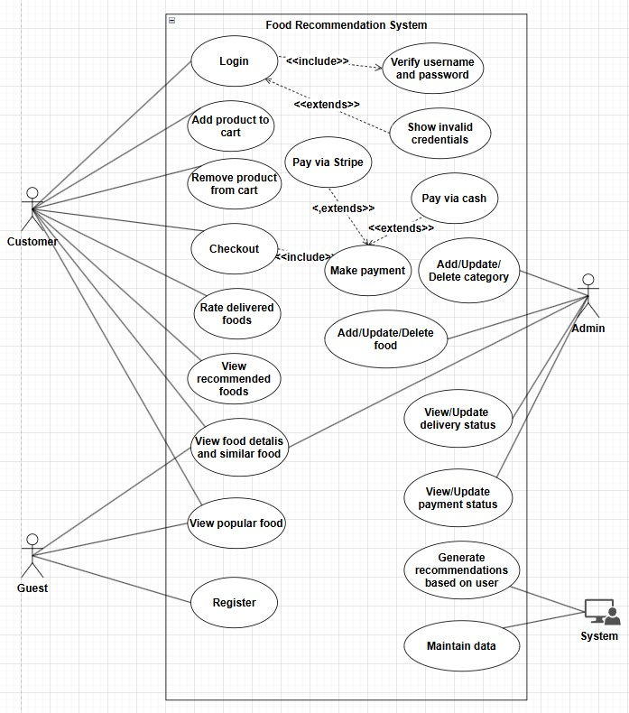

Figure 2: Use Case Diagram for Food Recommendation System

ii. Non-Functional Requirements
Non-Functional Requirements are those requirements which define the quality attributes, performance, and constraints of a system, such as reliability, scalability, usability, and security.
- Performance: The system will run smoothly as long as the system configurations supports the minimum requirements (i5 8th Gen, 8 GB Ram, 256 SSD, Windows 10) and stable internet connection. We haven’t used external service APIs and animation in our system which improved our performance. Moreover, size of our dataset is small which doesn’t take long time to recommend food items to user.
- Security: The system ensures authentication using email and password authentication. It provides authorization based on user roles which are admin and user. User password is hashed before saved in database. Only the registered user can add food items to their cart. Our system has integrated secure payment gateway through Stripe.
- Easy Access: Food recommendation system is easily accessible anywhere using a desktop with a stable internet connection to purchase food items.
- Usability: Food recommendation system is user friendly and user don’t require a high level of knowledge and computer skills to access the website. It uses simplified interface, navigation and UI to improve the recommendation system.

3.1.2 Feasibility Analysis
Feasibility Analysis is the process of studying whether a project or system is feasible and achievable. It checks whether the project can be completed within the budget, time and technical capabilities while also meeting the needs of the user.

i. Technical Feasibility
We have used different programming and database tools such as Next JS, Express JS and MongoDB which are easily accessible. Since the domain knowledge required for this project are also available easily on the internet. We can say that the food recommendation system is technically feasible.
ii. Operational Feasibility:
Since the proposed system will meet the requirements of the customers as well as clients and will be available for the customers for recommending foods online.
Thus, the food recommendation system is operationally feasible.

iii. Economic Feasibility
Since the proposed system requires minimum equipment to develop the system cost of expenses in APIs and Database are excluded. The member who wants to work through the system will manage the products, profiles, etc. themselves. However, the developer of the system can earn money by taking minimum fees from the member who wants to use the system. Hence, we can conclude that the proposed system is economically feasible.

iv. Schedule Feasibility
The project expands over a period of 80 days with Task being divided along with duration in the time frame. In order for the system to be delivered in the specified time frame we have to make sure deadlines are met and tasks are executed accordingly in the specified duration period.
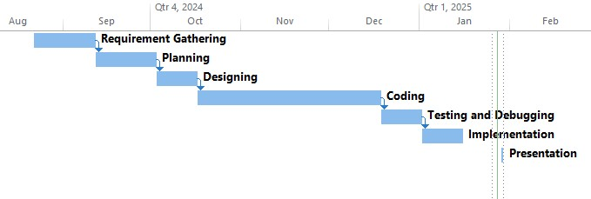

Figure 3: Gantt Chart for Food Recommendation System

3.1.3 Analysis
We have performed system analysis by using ER Diagram for data modelling and DFD for process modelling.
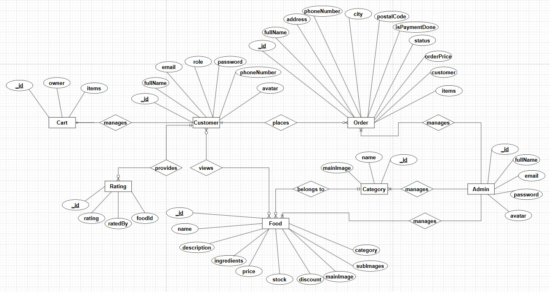
ER Diagram

Figure
4
:
ER diagram for Food Recommendation System

The ER diagram represents a database for a food recommendation system. The User entity stores customer details and connects to Cart, Order, and Rating entities to manage user activities like orders, ratings, and cart items. The Food entity holds details about food items, linking to the Category entity for classification and the Rating entity for user feedback. The Order entity tracks order details such as payment, status, and customer information, while the Cart entity manages selected items for purchase. The Category entity organizes food into categories. Relationships ensure proper linking between users, food, orders, and their respective attributes for smooth system functionality

DFD Level 0
The context level data flow diagram describes the whole food recommendation system. The Level 0 DFD describes all users who operate the system. The Figure below shows DFD of the proposed system.
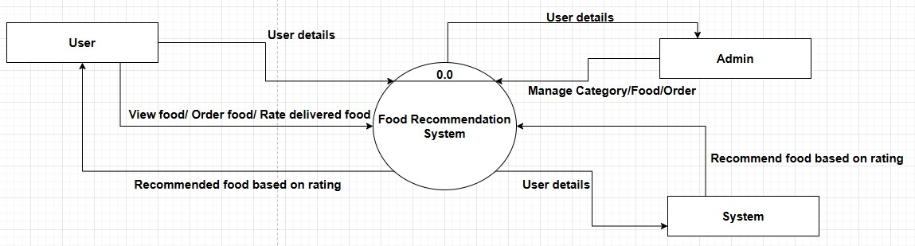
Figure 5: DFD Level 0 for Food Recommendation System

DFD Level 1
The DFD Level 1 describe the functionality such as user registration, login, view food details, add to cart and recommend food for unrated item for user. Similarly, admin can manage category, food and order.
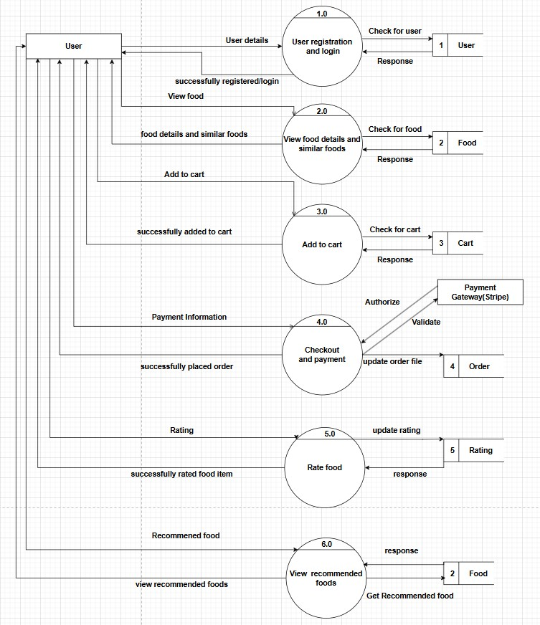

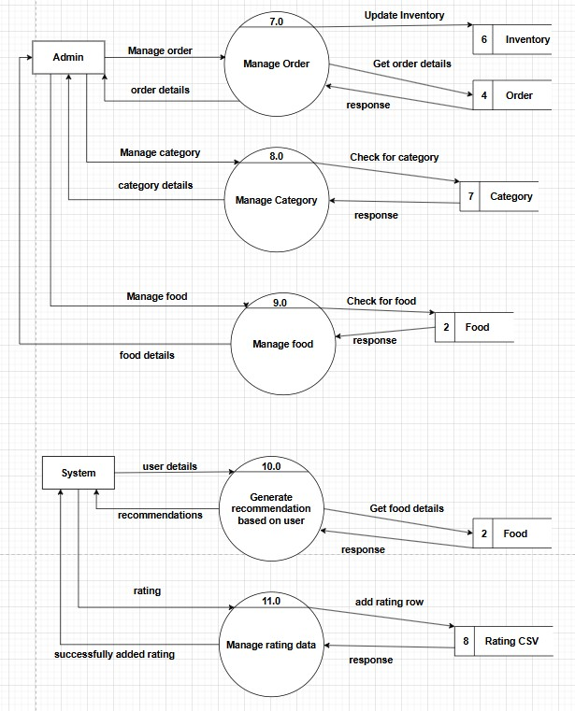
Figure 6: DFD Level 1 for Food Recommendation System

Chapter 4: System Design

4.1 Design

4.1.1 Database Design
The Schema design for Food Recommendation System is as below:
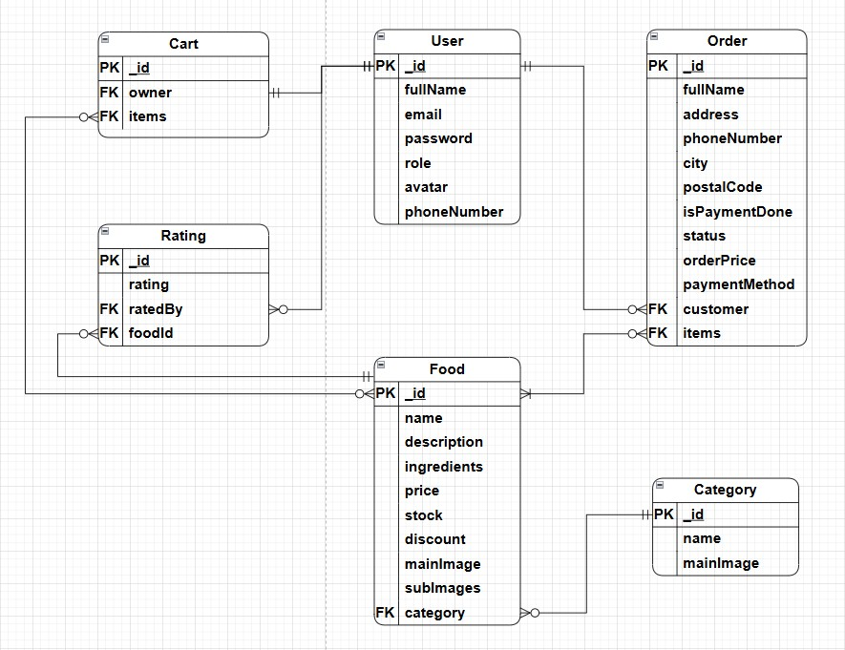

Figure 7: Database Design for Food Recommendation System

4.1.2 Forms Design
Form design refers to the process of creating and structuring forms in a way that makes it easy for users to input information. Different forms that are used in food recommendation system includes the following:

• In the customer side
- Form for Sign Up & Sign In
- Form for Updating Profile, Updating Password, Reset Password.
- Form for Order / Checkout

• In the admin side
- Form for Adding/Updating Category
- Form for Adding/Updating Foods
- Form for Updating Orders

4.2 Algorithm Details
The system uses two major algorithms: SVD for recommending food items based on useritem interactions and Cosine Similairty for displaying similar food items based on ingredients.

SVD
SVD is a powerful matrix factorization technique used in model-based collaborative filtering to generate recommendations by reducing high-dimensional data into simpler structures. It captures latent features in user-item interactions and helps predict missing ratings [11].

Steps in SVD Algorithm

1. Matrix Representation
Represent the data as a user-item matrix R, where rows correspond to users, columns correspond to items and values represent the ratings given by users to items (missing ratings are left as 0).
Example:
User\Food | Food1 | Food2 | Food3 | Food4
User1 | 5 | 3 | 0 | 1
User2 | 4 | 0 | 0 | 1
User3 | 1 | 1 | 0 | 5
User4 | 0 | 0 | 4 | 4
User5 | 0 | 1 | 5 | 4

2. Decompose the Matrix Using SVD
SVD decomposes the matrix R into three matrices:
R=UΣV^{T}
Where,
- U: A matrix of user latent features (orthogonal, size m×k).
- Σ: A diagonal matrix of singular values, representing the importance of each latent feature (size k×k).
- V^{T}: A matrix of item latent features (orthogonal, size k×n).
After SVD is performed these three matrices are obtained:
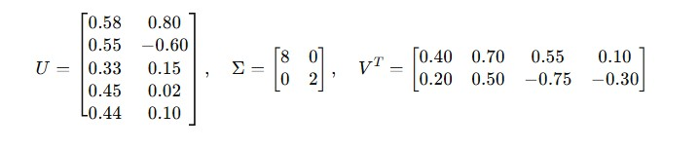

3. Reduce Dimensionality
To simplify the computation, reduce Σ to only the top k singular values and corresponding columns in U and V^{T}. This step retains the most important latent features while discarding noise.
Example: Keep the top 2 singular values in Σ:


4. Predict Missing Ratings
Reconstruct an approximation of the original matrix R using the reduced U, Σ, and V^{T}:
The missing ratings are now filled in with predicted values.
User\Food | Food1 | Food2 | Food3 | Food4
User1 | 4.9 | 3.1 | 2.8 | 1.2
User2 | 4.2 | 2.5 | 2.0 | 1.1
User3 | 1.1 | 1.0 | 3.0 | 4.9
User4 | 1.3 | 1.5 | 4.0 | 4.0
User5 | 2.0 | 1.8 | 4.8 | 4.2

5. Generate Recommendations
For each user, identify the highest predicted rating for food items they haven’t rated. These become the recommended items.
Example: For User1, the model predicts the highest rating (2.8) for Food3, which the user hasn’t rated. So, recommend Food3 to User1.

TF-IDF
TF-IDF is a statistical measure used to evaluate the importance of a word in a document relative to a collection of documents. The key idea of TF-IDF is to assign a weight to each word based on how frequently it appears in a document and how unique it is across all documents [4].
TF measure how often a term t appears in a document d.
Number of times t appears in document d
TF (t, d)=
Total number of terms in document d IDF measure how unique a term is across all documents in dataset.
Total number of documents in datset D
IDF (t, D)= log⁡()
Number of documents containing the term t
TD-IDF gives weight to each term in a document.
TF-IDF (t, d) =TF (t, d) * IDF (t, D)

Cosine Similarity
Cosine Similarity is a metric used to measure the similarity between two non-zero vectors in a multi-dimensional space. It calculates the cosine of the angle between the two vectors, which represents how closely related the two vectors are. In our project, it is used to show similar food items based on ingredients.

Chapter 5: Implementation and Testing

5.1 Implementation
We have used following tools to implement and test our system.

5.1 Tools Used

Design and Development Tools
- Draw.io: Draw.io is an online tool for creating diagrams, flowcharts, and organizational charts. It’s free, easy to use, and works directly in your web browser or as an app [12].
- VS Code: VS Code (Visual Studio Code) is a lightweight yet powerful code editor used by developers for writing and editing code. It supports multiple programming languages, extensions, and features like syntax highlighting, debugging, and version control integration.
- MS Project: MS Project is a project management tool by Microsoft that helps users plan, schedule, and track the progress of tasks. It’s great for creating timelines, assigning tasks to team members, and managing resources effectively.
- MS Word: MS Word is a popular word-processing software used for creating, editing, and formatting documents. It offers a range of tools like spell-check, templates, and text formatting to make professional-looking documents easily.

Front End Tools
- Next JS: Next.js is a React-based framework for building modern web applications. It supports features like server-side rendering, static site generation, and API routes, making it ideal for creating fast and SEO-friendly websites.
- Tailwind CSS: Tailwind CSS is a utility-first CSS framework that allows developers to style their websites directly in the HTML or JSX using predefined classes. It’s flexible and speeds up development by eliminating the need to write custom CSS from scratch.
- Material UI: Material-UI (MUI) is a React component library that provides predesigned components based on Google’s Material Design guidelines. It allows developers to build visually appealing user interfaces with less effort.

Back End Tools
- Node JS: Node.js is a powerful, open-source runtime environment that allows developers to run JavaScript on the server side. It’s built on Chrome’s V8 JavaScript engine, enabling fast and efficient execution of code.
- Express JS: Express is a lightweight web application framework for Node.js that is commonly used to build server-side applications and APIs. It’s easy to use, highly flexible, and supports middleware to handle requests and responses efficiently.
- Python: Python is a versatile, high-level programming language known for its simplicity and readability. Its broad range of libraries and frameworks makes it suitable for web development, data analysis, machine learning, automation, and more.

Database Tools
• MongoDB: MongoDB is a NoSQL database that stores data in a flexible, JSON-like format called BSON. It’s ideal for handling large amounts of unstructured or semistructured data and is widely used in modern applications. Its flexibility and scalability are great for developers, but learning its querying syntax can take some time for those new to NoSQL databases.

5.2 Testing

5.2.1 Test Cases for Unit Testing
Unit testing is a process where small parts of a program, called "units," are tested individually to ensure they work as expected. Each unit, like a function or a method, is tested in isolation to check if it produces the right results for given inputs. This helps catch errors early in development and makes the code easier to maintain and debug. Unit testing ensures that each piece of the program works correctly before they are combined into the larger system.

Table 1: Test Cases for Registration
Test Case  ID | Test Case Description | Expected Result | Actual Result
1 | User register with valid full name, email, phone number, password, confirm password. | User should be directed to the login page. | Successfully directed to the login page.
2 | User register using invalid details. | User should stay in the same page. | Shows error message and stays in the same page.

Table 2: Test Cases for Login
Test Case  ID | Test Case Description | Expected Result | Actual Result
1 | User login using valid email and password. | User should be directed to the main page. | Successfully directed to the main page.
2 | User login using invalid details | User should stay in the same page. | Shows error message and stays in the same page.

Table 3: Test Cases for Add to Cart
Test Case  ID | Test Case Description | Expected Result | Actual Result
1 | Add To Cart is pressed for a particular product. | The product should be added to the cart. | The cart was  updated successfully.
2 | The quantity for the product was increased. | The total quantity and the price should be increased. | The total quantity and the price  increased successfully.
3 | The quantity for the product was decreased. | The total quantity and the price should be decreased. | The total quantity and the price decreased successfully.

Table 4:Test Cases for Rating
Test Case  ID | Test Case Description | Expected Result | Actual Result
1 | After the food is delivered, particular food is shown in the MyRating Page and user presses the recommended rating for that product. | New row should be added for the user in  sample_data.csv file for future recommendation. | Data was added successfully in the sample_data.csv file.

5.2.2 Test Cases for System Testing
System testing is the process of testing the entire software application as a whole to ensure that it meets the specified requirements. It involves checking all components of the system, including software, hardware, and network interactions, to verify they work together properly. The goal is to identify any defects or issues in the complete system before it is released. System testing typically includes functional testing, performance testing, security testing, and other tests to ensure that the system behaves as expected in various scenarios.

Table 5: Test Cases for Recommendation System
Test Case  ID | Test Case Description | Expected Result | Actual Result
1 | User register with valid details | User should be directed to the login page. | Successfully directed to the login page.
2 | User login using valid details | User should be directed to the main page. | Successfully directed to the main page.
3 | Navigate to the food detail page and click on add to cart button. | The food should be added to the cart. | The cart was  updated successfully.
4 | Proceed to checkout button is pressed. | Shipping form should be displayed. | Shipping form was displayed.
5 | If user selects one of Payment method i.e. Cash on Delivery. | User should be directed to the order page. | User was directed to the order review page.
6 | If user selects one of Payment method i.e. Stripe Payment. | User should be directed to the stripe payment test mode. | User was directed to stripe payment test mode and Credit card form was shown.
7 | After the food is delivered, particular food is shown in the MyRating Page and user presses | New row should be added for the user in | Data was added successfully in the
 | the recommended rating for that product. | sample_data.csv file for future recommendation. | sample_data.csv file.

Chapter 6: Conclusion and Future Recommendations

6.1 Conclusion
Food Recommendation System based on model-based collaborative filtering was implemented successfully. After performing background study and literature review of food recommendation systems, we decided to integrate recommendation features in our restaurant website for personalized recommendations. Evolutionary prototyping was the selected development methodology as the initial requirement was concise and clear which helped to build the prototype of the system. Based on the initial requirements, the development was further proceeded with multiple iteration while making necessary changes till the intended system was developed. Testing was done in each iteration based on the requirements. To ensure this, unit testing was done on each component of system, followed by system testing to confirm the proper functionality of the system. Using this system, the customer would be able to view food details along with other similar food items based on ingredients, buy food, rate delivered food and receive recommendations based on the ratings provided. The recommendation is provided by predicting the ratings for unrated food items using SVD model.

6.2 Future Recommendations
Since we have used a collaborative filtering algorithm for the recommendation, it is recommended to use a large data set to make the recommendation for better accuracy. In the future, we can develop a mobile application for our recommendation system to make it more accessible everywhere. We can also add user reviews in our system to better understand individual preferences and to increase credibility. In addition, we can also increase the number of food items in our menus to provide wider range of user preferences.
By implementing these future recommendations, Food Recommendation System could continue to evolve and improve, providing better recommendation to the customers.

References

- S. H. S. B. B. Z. H. Aamir Fareed, "A collaborative filtering recommendation framework utilizing socialnetworks," ScienceDirect, vol. 14, pp. 1-16, 15 December 2023.
- D. V. N. L. N. Minh-Phung Thi Do, "Model-based approach for Collaborative Filtering," in The 6th International Conference on Information Technology for Education, Ho Chi Minh city, Vietnam, 2010.
- F. Karabiber, "learndatasci.com," [Online]. Available:
https://www.learndatasci.com/glossary/tf-idf-term-frequency-inverse-documentfrequency/#:~:text=What%20is%20TF-IDF%3F%20Term%20Frequency%20%20Inverse%20Document,collection%20of%20documents%20%28i.e.%2C%2 0relative%20to%20a%20corpus%29.. [Accessed 17 September 2024].
- N. N. Qomariyah, "international.binus.ac.id," Binus University, 03 Nov 2020. [Online]. Available: https://international.binus.ac.id/computerscience/2020/11/03/definition-and-history-of-recommender-systems/. [Accessed 17 Sep 2024].
- P. P. F. R. M. Z. Dietmar Jannach, "Recommender systems: Past, present, future," Recommender System, vol. 42, no. 3, pp. 3-6, 2021.
- R. S. Richa Sharma, "Evolution of Recommender Systems from Ancient Times to Modern Era: A Survey," Indian Journal of Science and Technolog, vol. 9, no. 20, p.
10, 2016.
- P. Timilsina, "onlinekhabar.com," 31 Jan 2023. [Online]. Available:
https://english.onlinekhabar.com/e-commerce-in-nepal-future.html. [Accessed 18 Sep 2024].
- "thamel.com," Thamel, [Online]. Available: https://thamel.com/about.html.
[Accessed 18 Sep 2024].
- "foodmandu.com," Foodmnadu, [Online]. Available: https://foodmandu.com/Home/About. [Accessed 18 Sep 2024].
- "daraz.com.np," Daraz, [Online]. Available:
https://pages.daraz.com.np/wow/i/np/about-us/about-
us?spm=a2a0e.tm80335409.footer_top.5.963c501f7DuN18&hybrid=1&scm= 1003.4.icms-zebra-100024112-2954385.OTHER_5486967089_2597685.
[Accessed 18 Sep 2024].
- V. Athitsos, "athitsos.utasites.cloud," University of Texas , 2 Sep 2021. [Online].
Available:
https://athitsos.utasites.cloud/courses/cse4309_fall2018/lectures/13_svd.pdf.
[Accessed 1 Nov 2024].
- "diagrams.net," JGraph Ltd and draw.io AG, [Online]. Available: https://app.diagrams.net/. [Accessed 22 Dec 2024].

Appendices
Some of the screenshots of the system are as follows:
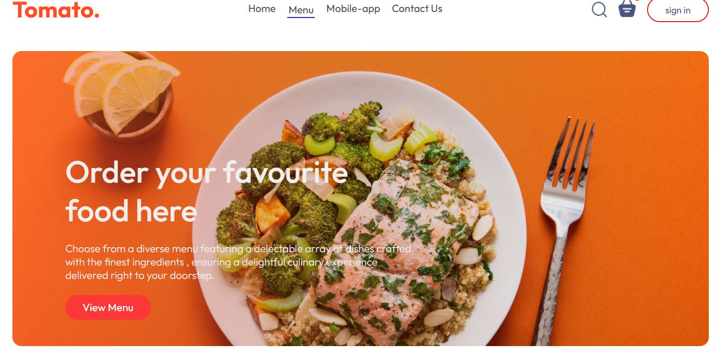

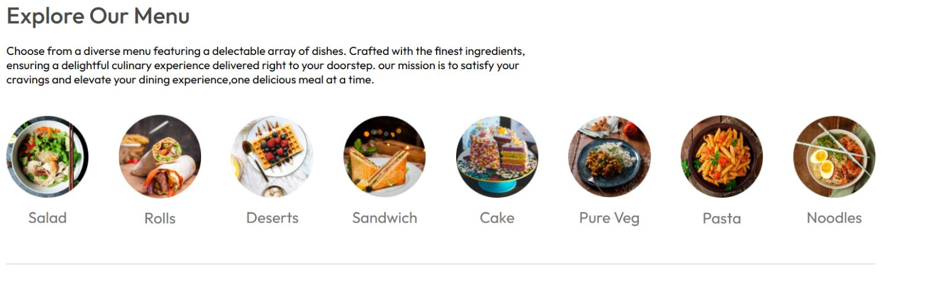
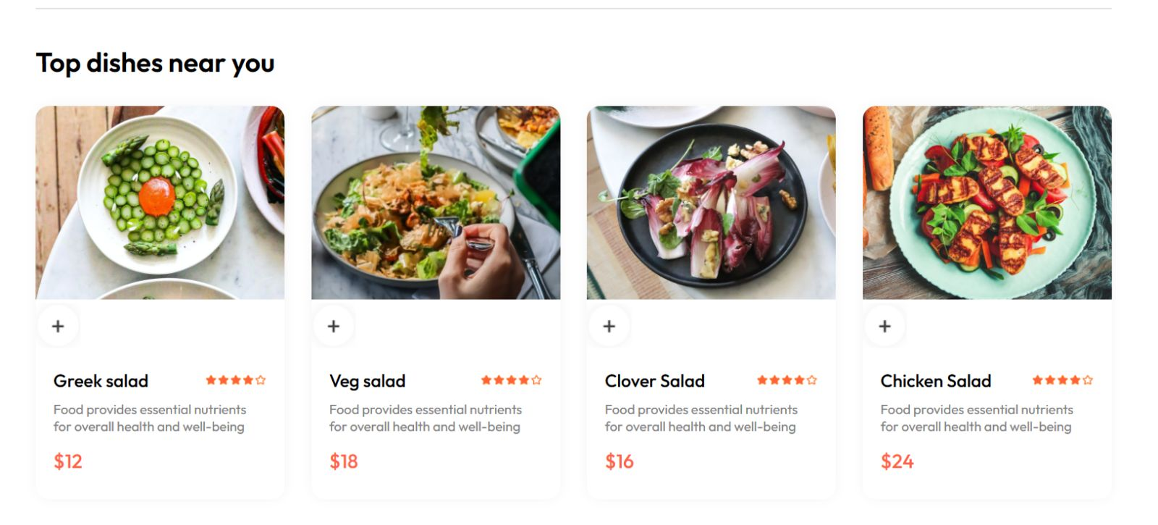

Screenshot 1 Home Page of system

